Advanced Structural Modeling

Advanced Classes
- Classifier
- A modeling element that describes structural features (attributes) and behavioral features (operations).

- A modeling element that can have instances.

- UML classifiers
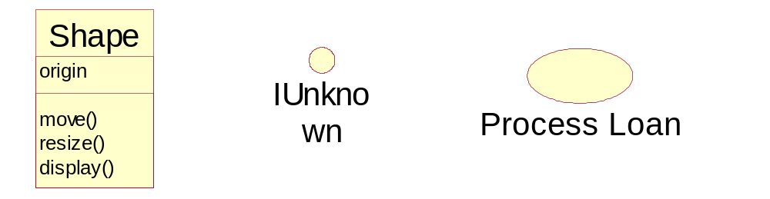

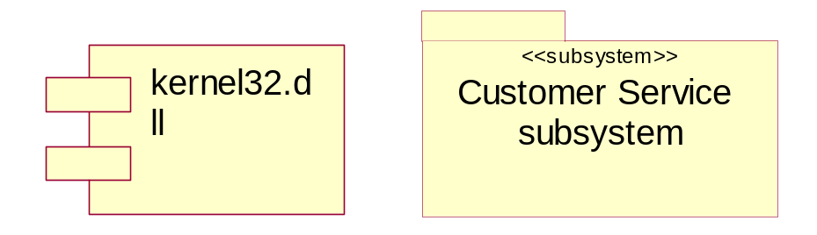
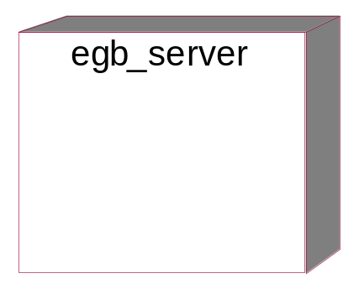

- Visibility
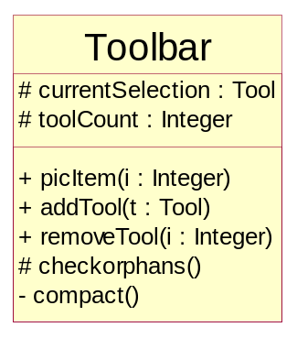
- Public
- Protected
- Private

- Scope
- Instance
Each instance of the classifier holds its own value for the feature.

- Classifier
There is just one value of the feature for all instances of the classifier.

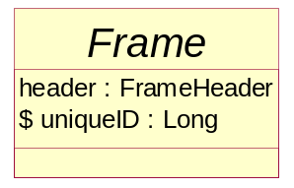

- Abstract, Root, Leaf, and Polymorphic Elements
- Abstract class: no instance, unimplemented operation(s)
- Concrete class: has instance(s) and all operations are implemented.
- Abstract operation: no implementation
- Root class: no parent class or super class
- Leaf class: no subclasses
- Leaf operation: cannot be overridden or redefined by subclasses
- Polymorphic operation: can be overridden or redefined by subclasses.

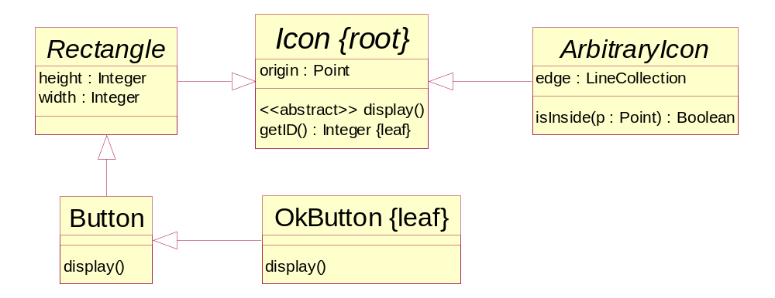

- Multiplicity
- Number of class instances
- Number of elements of an array attribute

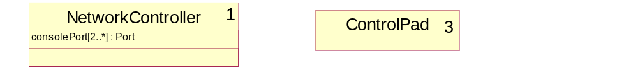

- Attribute specification
- Full form
[visibility] name [multiplicity] [:type] [=initial-value] [{property}]

- Standard properties
- changeable
- addOnly: add element(s) only, no remove
- frozen: no value change

- Operation specification
- Full form
[visibility] name [(parameter-list)] [:return-type] [{property}]

- Standard properties
- leaf: cannot be overridden
- isOuery: does not change state
- sequential: semantics of concurrent calls cannot be guaranteed.
- guarded: sequencing and synchronizing concurrent calls
- concurrent: semantics of concurrent calls are guaranteed

- Parameter specification
- Full form
[direction] name : type [=default-value]

- Standard directions
- in: an input parameter with input value, may not be modified
- out: an output parameter, without input value, may be modified
- inout: an input parameter with input value, may be modified

- What is a utility class
- A class with stereotype <<utility>> whose all attributes and operations have classifier scope (i.e. static).

- Example: <<utility>> Math

- Advanced Relationship
- Association
- Navigation
- Association (role) visibility
- Public: can be seen outside of the association
- Private: cannot be seen outside of the association
- Protected: can be only seen by subclasses of the association
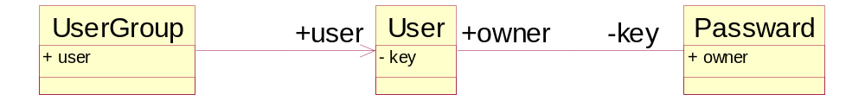

- Qualification through Qualifier
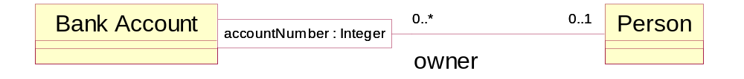

(bankAccount, accountNumber) → 0 or 1 person
person → many(bankAccount, accountNumber)

- Association class
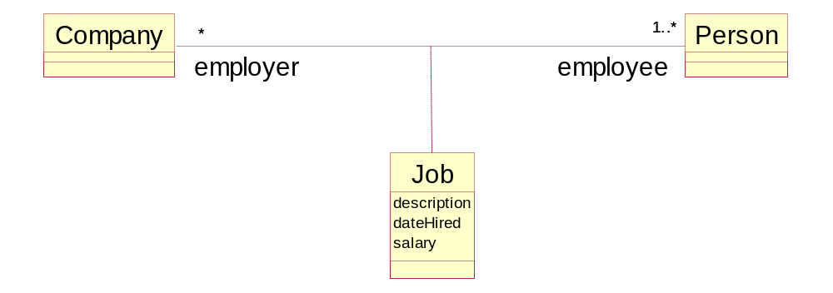

- Realization
- What
A realization is a semantic relationship between classifiers in which one (target) classifier specifies a contract that another (source) guarantees to carry out.

- Where to use
- A class realizes an interface
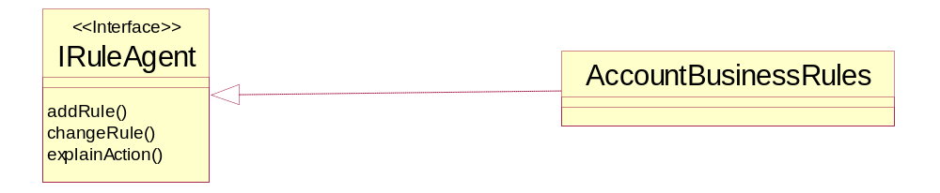

- A component realizes an interface
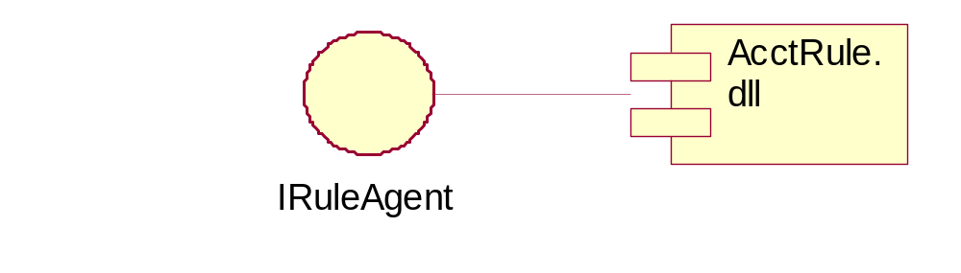

- A use-case realization realizes a use case or realization

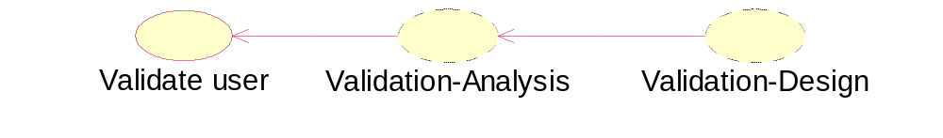

- Interfaces
- What is an interface
- An interface is a collection of operations that are used to specify a service of a class or component.

- An interface does not specify any structure (attributes) nor any implementation of the operations in the collection.

- An interface defines a line between the specification of what an abstraction does and the implementation of how that abstraction does it.

- Relationships between interfaces and other classifiers
- A class can realize one or more interfaces

- An interface can be realized by one or more interfaces

- A class can depend on an interface

- Inheritance relationship between interfaces

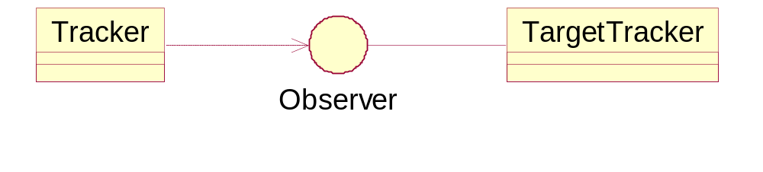

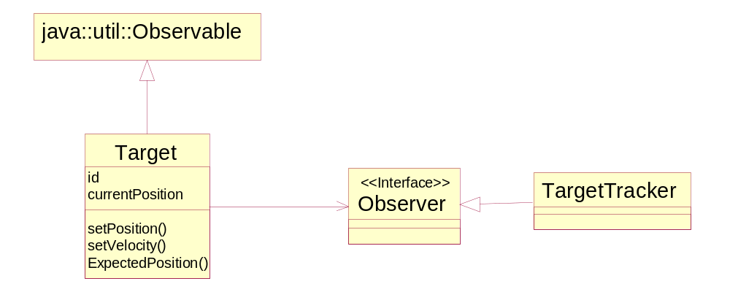

- Interface for role

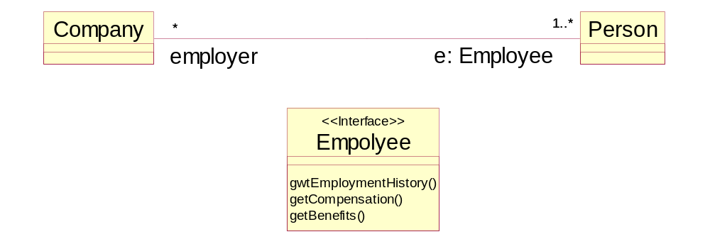

- Packages
- What is a package
- A package is a general-purpose mechanism for organizing elements into groups.

- Owned elements
- A package can own other elements, even other packages.

- Every element is uniquely owned by exactly one package.

- A package forms a name space. Two elements owned by two different packages may have the same name.
Examples:
BuyerPackage::Information class
SellerPackage::Information class

- Elements of different kinds may have the same name
Example:
BuyerPackage::Information class
BuyerPackage::Information component

- Path names in nested packages
Example:
CustomerPackage::BuyerPackage::Information class

- Visibility of owned elements
- Public (+)
- Private (-)
- Protected (#)

- A package exports all its public elements
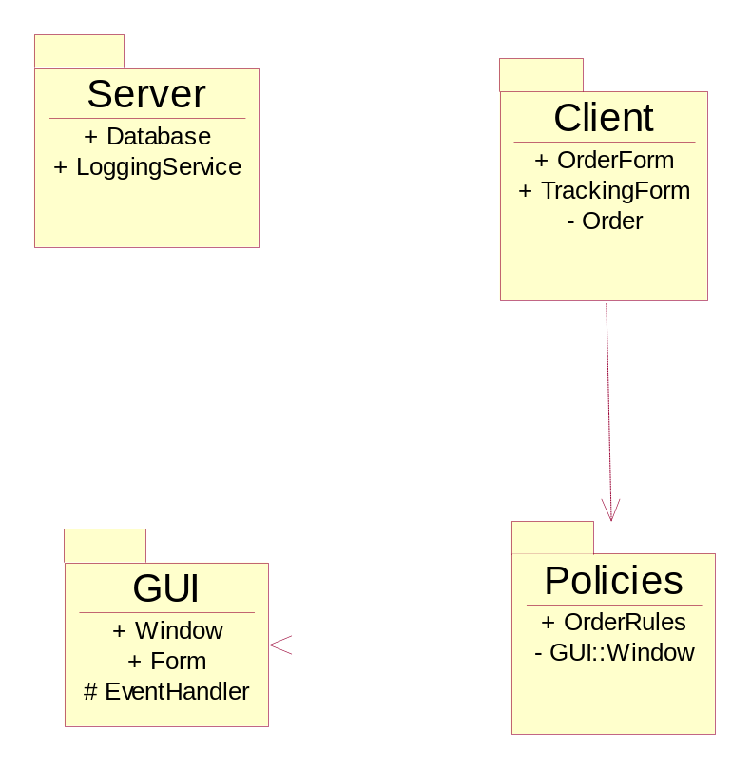

- Subsystem – a stereotyped package
- It is a package of elements treated as a unit, including a specification of the behavior of the entire package contents as a coherent unit.

- A subsystem is modeled both as a package and as a class.

- A subsystem has a set of interfaces that describe its relationship to the rest of the system

